**Task Analysis and User Flows using lucidchart**

230701278

Saira Banu M

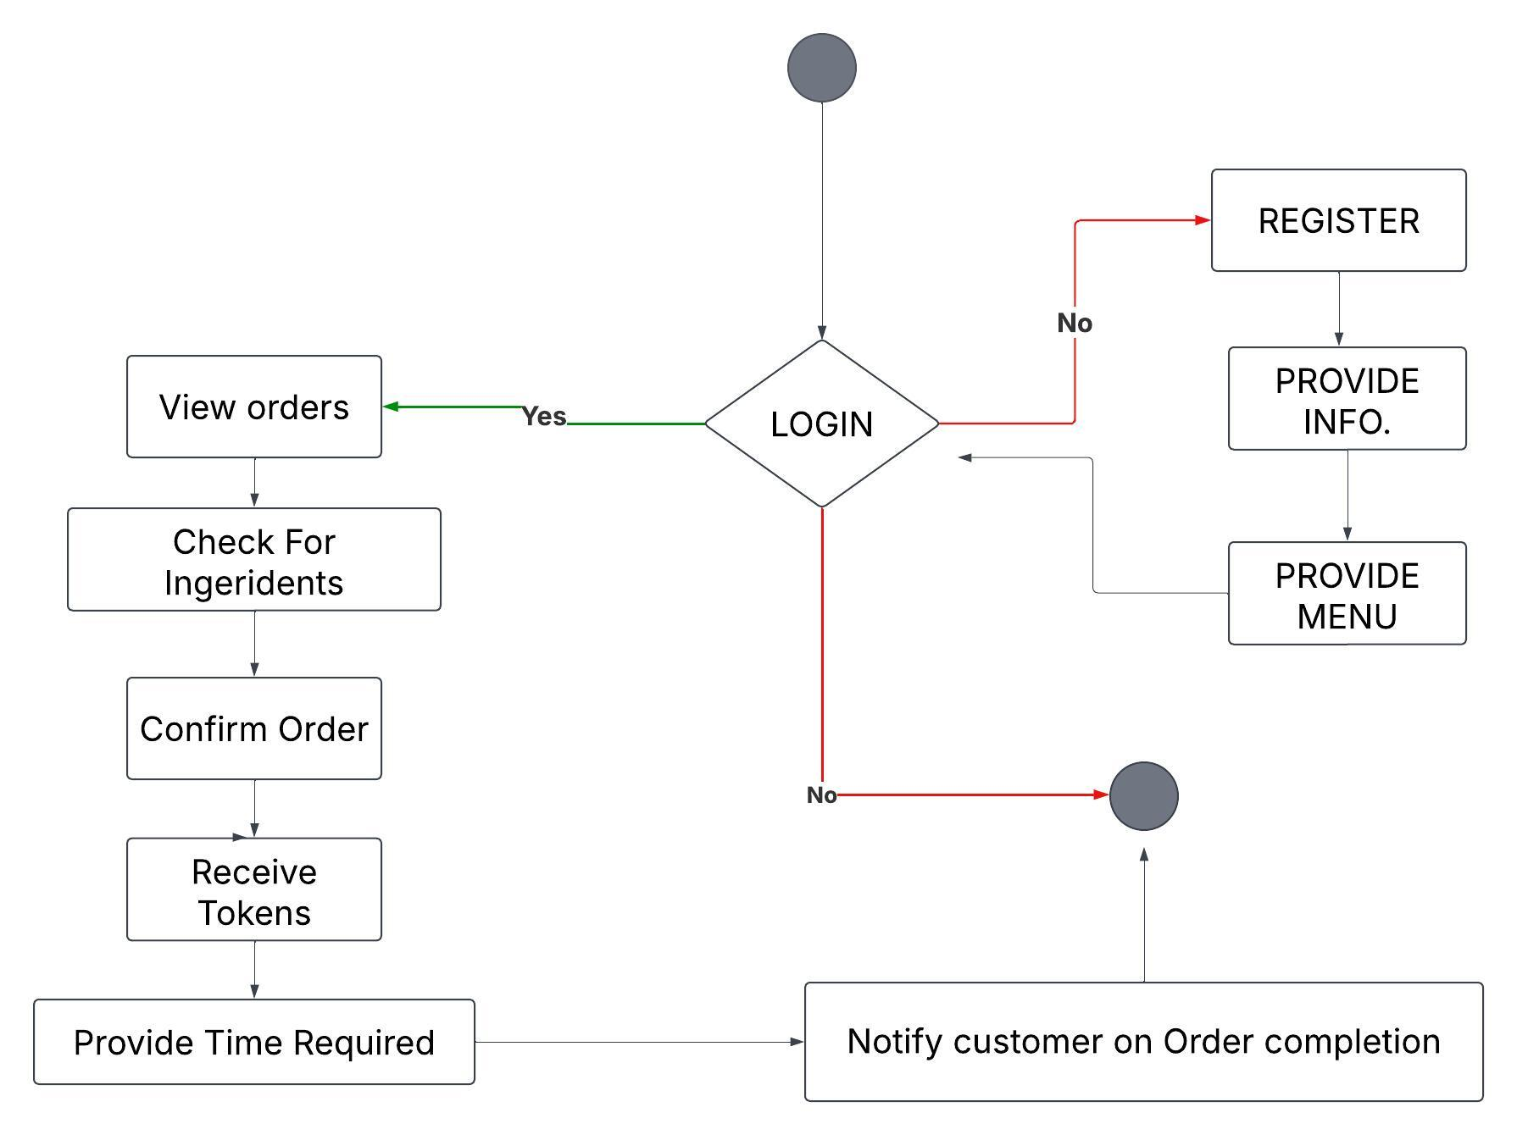

# Shapes and Their Meanings

• Ovals (Start, End): Represent the beginning and end of the process.

• Rectangles (Processes): Represent actions such as visiting the website, home screen navigation, and order confirmation.

• Diamonds (Decisions): Represent decision-making points, such as user authentication and checkout.

• Arrows: Show the logical flow from one step to another.

### 1. Introduction

This document outlines the workflow of an order processing system. It covers the tasks involved, user flow, and task analysis.

### 2. System Overview

The system allows users to log in, view orders, check ingredient availability, confirm orders, generate tokens, and provide estimated time for completion. Users who do not have an account must register and provide information before proceeding.

### 3. Task Analysis

**3.1 Tasks Involved**

1. **Login Process:**
   * Users log into the system.
   * If login fails, users are redirected to registration.
2. **Registration Process (if not logged in):**
   * Users must provide required information.
   * System stores detail and provides access to the menu.
3. **Order Processing:**
   * Users can view available orders.
   * System checks the availability of ingredients.
   * If ingredients are available, the order is confirmed.
   * A token is generated for tracking the order.
   * Estimated time for order completion is provided.
4. **Notification:**
   * Once the order is completed, the system notifies the customer.

### 4. User Flow

**4.1 Login Flow**

* **User logs in → Successful?**
  + **Yes:** Proceed to order processing.
  + **No:** Redirect to registration.

**4.2 Registration Flow (if user is new)**

* **User registers → Provide information → Get menu access.**

**4.3 Order Processing Flow**

* **View Orders → Check Ingredients → Confirm Order → Generate Token → Provide Estimated Time.**

**4.4 Order Completion Flow**

* **Once the order is ready, the system notifies the customer.**

### 5. Conclusion

This system ensures a smooth and structured order processing workflow, from login to order completion, ensuring efficiency and user engagement.